# **Practical -1 Adnan Shaikh**

## Program to find if the number is even or odd

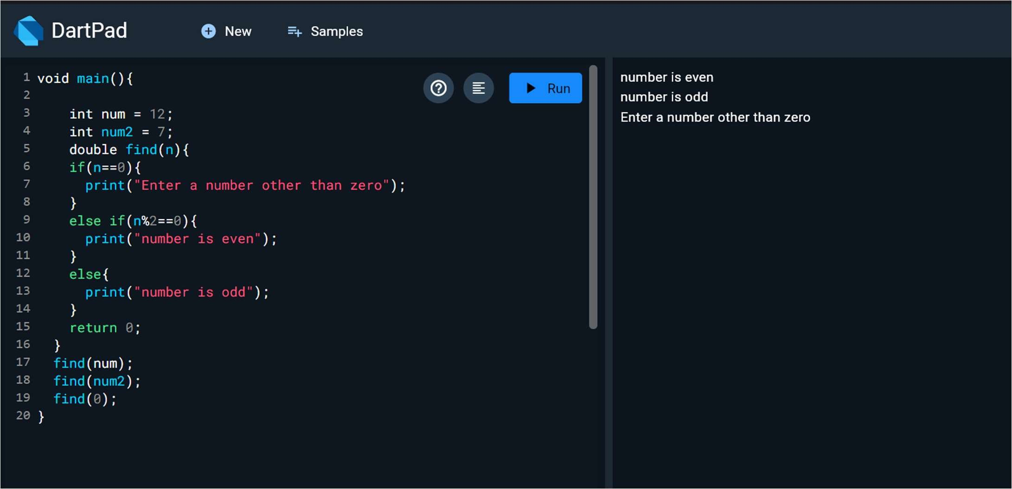

# **Practical -2 Adnan Shaikh**

## Program to find the greatest between 3 numbers

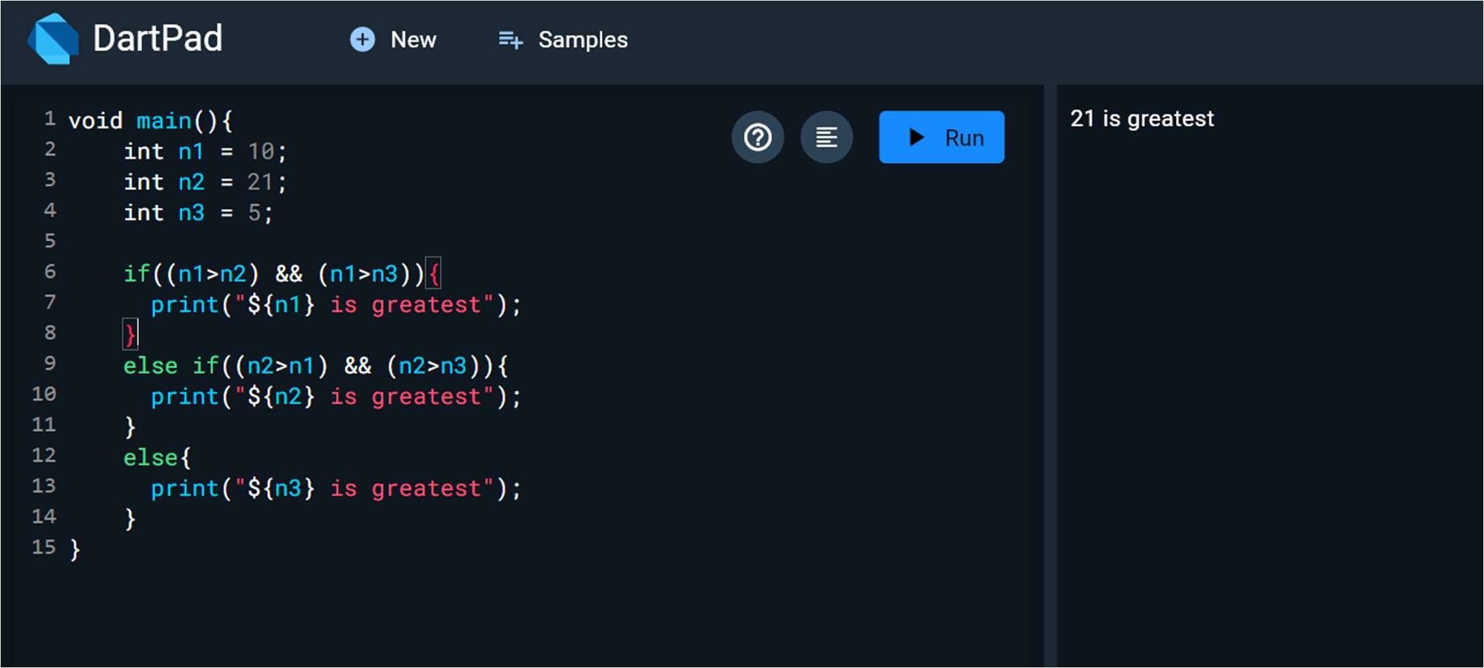

# **Practical -3 Adnan Shaikh**

## Program to print even numbers using for loop

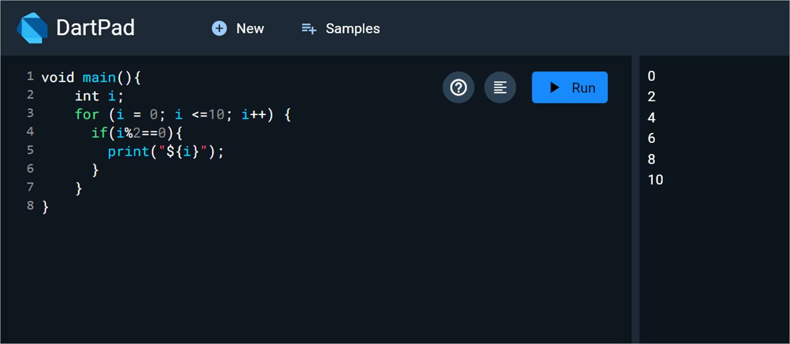

# **Practical - 4 Adnan Shaikh**

## Creating a simple UI home screen with appbar and body

import 'package:flutter/material.dart';

void main() => runApp( MaterialApp( home: Scaffold(

appBar: AppBar(title: Text("Welcome to Home page!")), body: Text("HEllo world!"),

),

),

);

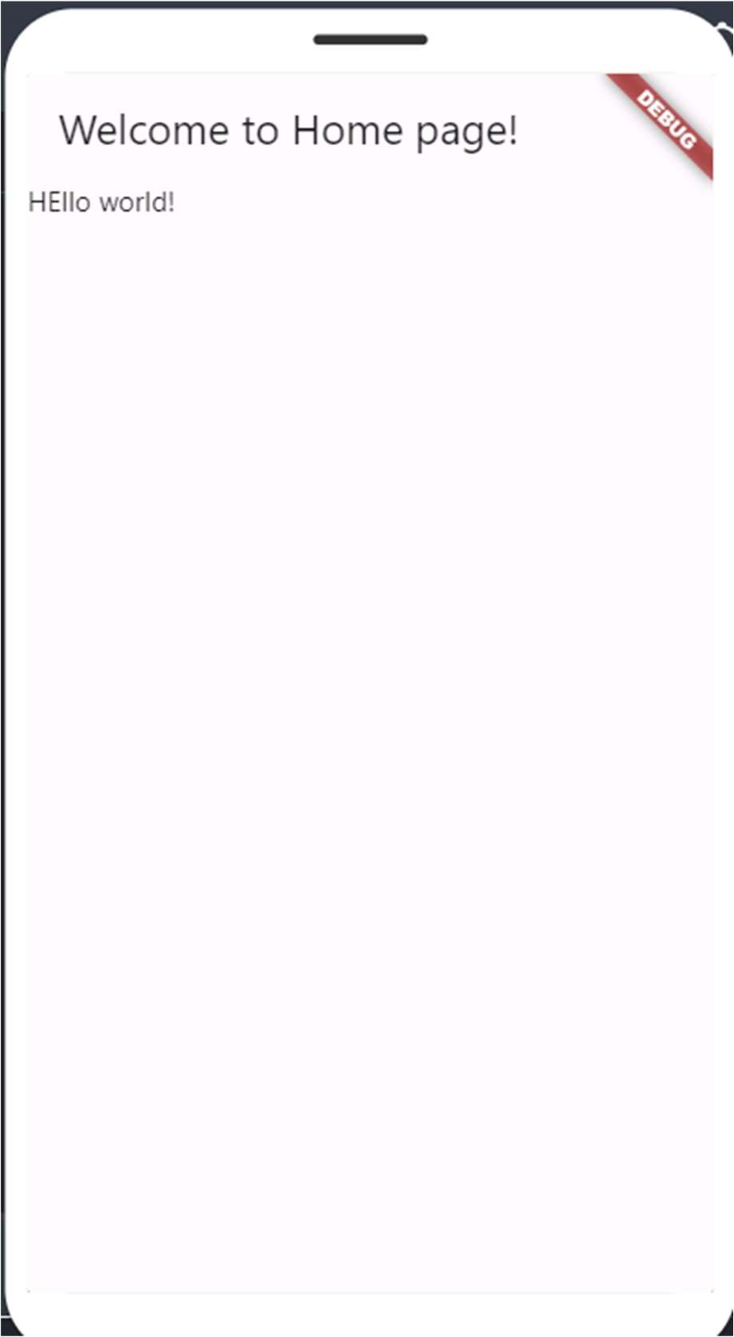

# **Practical -5 Adnan Shaikh**

# Implementation of center widget & floating button

import 'package:flutter/material.dart';

void main() => runApp( MaterialApp( home: Scaffold( appBar: AppBar(

title: Text("Welcome to Home page!"),

),

body: Center(child: Text("HEllo world")), floatingActionButton: FloatingActionButton( backgroundColor: Colors.green,

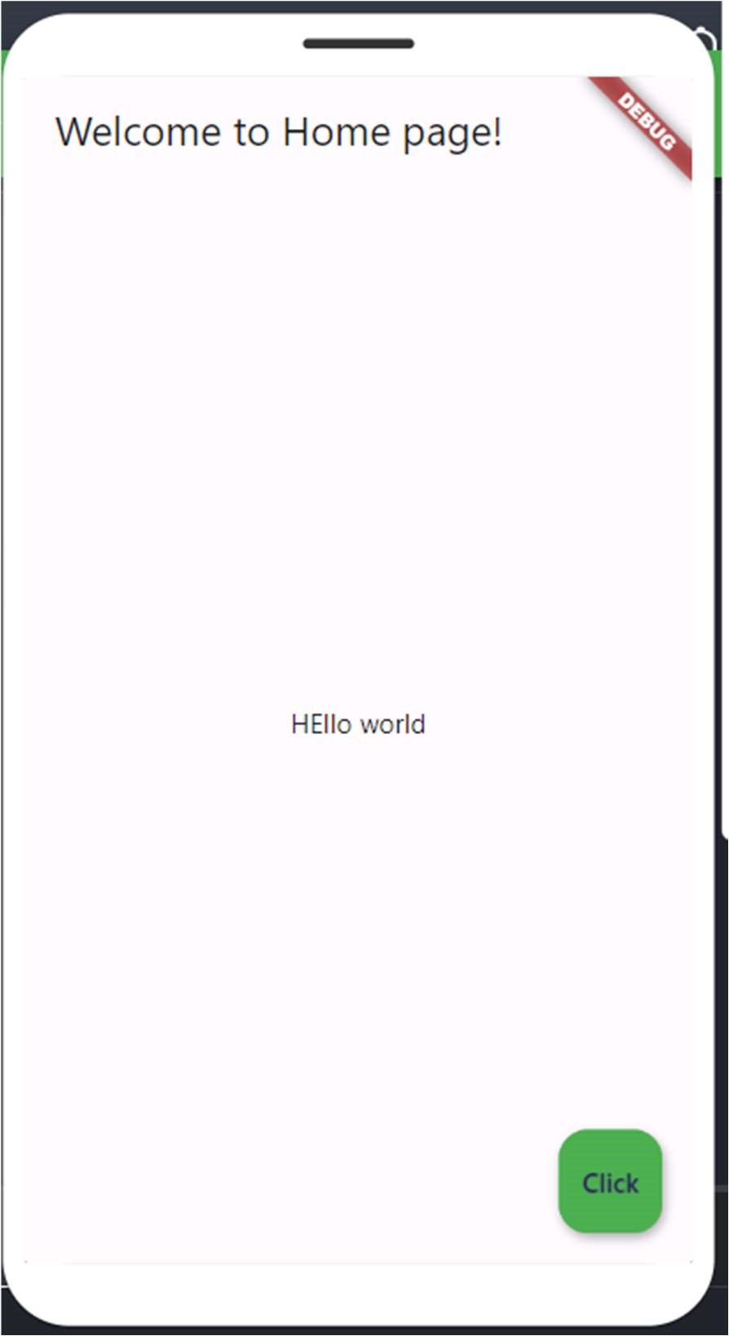 onPressed: () {},

child: Text("Click"),

),

),

),

);

# **Practical - 6 Adnan Shaikh**

## Implantation of image and attributes of image

import 'package:flutter/material.dart'; void main() => runApp( MaterialApp( home: Scaffold( appBar: AppBar(

title: Text("Welcome to Home page!"), backgroundColor: Colors.blue,

),

body: Center(

// child: Text("HEllo Adnan.!!"), child: Image.network(

"https://images.unsplash.com/photo-1532522750741628fde798c73?q=80&w=2070&auto=format&fit=crop&ixlib=rb-

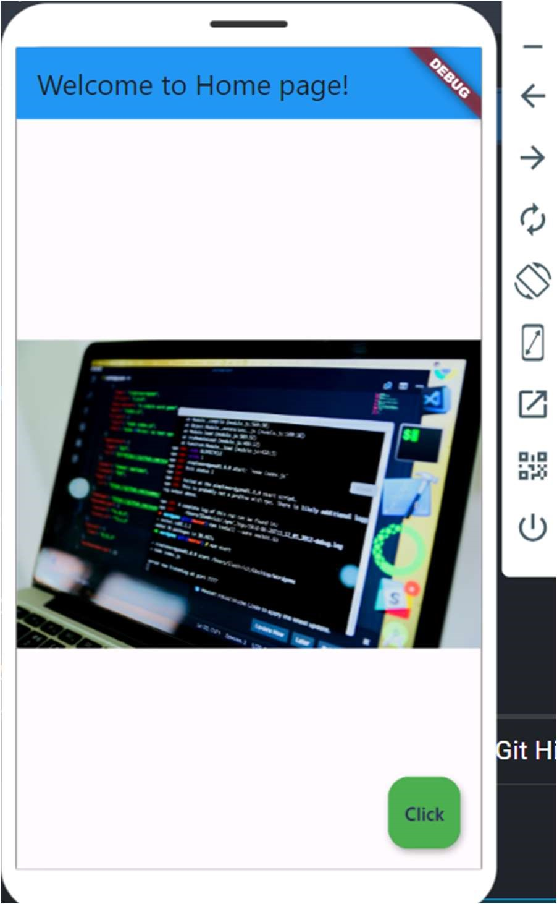4.0.3&ixid=M3wxMjA3fDB8MHxwaG90by1wYWdlfHx8fGVufDB8fHx8fA%3D%3D"),

),

floatingActionButton: FloatingActionButton(

backgroundColor: Colors.green,

onPressed: () {},

child: Text("Click"),

),

),

),

);

# **Practical - 7 Adnan Shaikh**

## Use of container and pdding

import 'package:flutter/material.dart'; void main() => runApp( MaterialApp( home: Scaffold( appBar: AppBar( backgroundColor: Color(0xff2f3031),

title: Text(

"Welcome to homepage", style: TextStyle( fontSize: 25, fontWeight: FontWeight.w700,

color: Colors.white ), ),

),

body: Column( children: <Widget>[ Container( color: Colors.cyan, padding: EdgeInsets.all(30),

child: Text("container 1"),

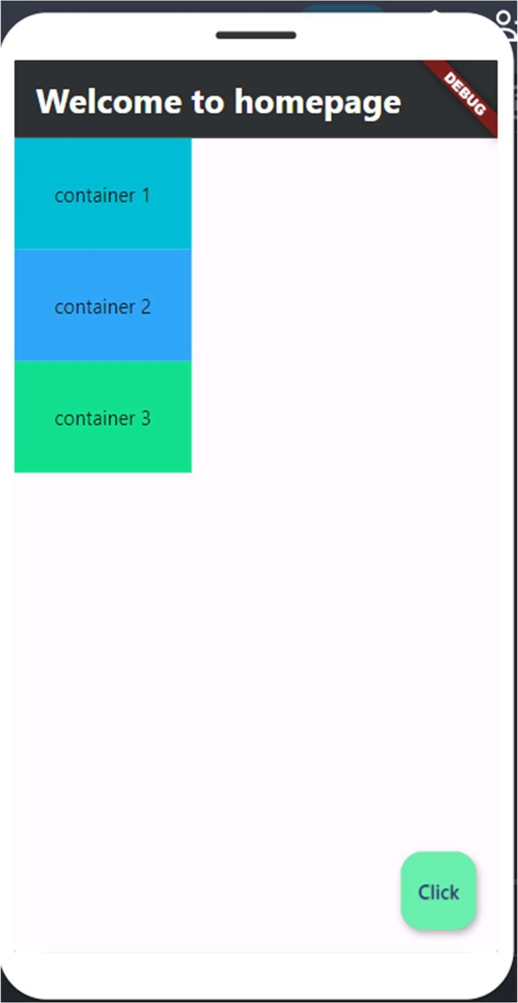 ),

Container( color: Color(0xff2ea6fa), padding: EdgeInsets.all(30),

child: Text("container 2"),

),

Container( color: Color(0xff11e18e), padding: EdgeInsets.all(30),

child: Text("container 3"),

),

],

),

floatingActionButton: FloatingActionButton( onPressed: () {},

backgroundColor: Colors.greenAccent, child: Text("Click"),

),

),)

# **Practical - 8 Adnan Shaikh**

## Inserting an image in containers, setting, style & Textstyle

import 'package:flutter/material.dart';

void main() => runApp( MaterialApp( home: Scaffold( appBar: AppBar(

backgroundColor: Color(0xff2f3031), title: Text(

"Welcome to homepage", style: TextStyle(

fontSize: 25,

fontWeight: FontWeight.w700,

color: Colors.white,

),

),

),

body: Column(

mainAxisAlignment: MainAxisAlignment.end, crossAxisAlignment: CrossAxisAlignment.center, children: <Widget>[ Container( color: Colors.cyan,

padding: EdgeInsets.fromLTRB(30, 40, 30, 60), child: Text(

style: TextStyle(fontSize: 20, fontWeight: FontWeight.w600),

"Yasir here"),

),

Container(

color: Color(0xff2ea6fa),

height: 200,

padding: EdgeInsets.fromLTRB(35, 40, 30, 30), child: Image.network(

"https://media.gettyimages.com/id/567577715/photo/purple-striped-jelly-

fish.jpg?s=612x612&w=gi&k=20&c=yjKgTBSoosM21Bk6krZXuJIX2WEos9-LRX9rFWyiFxU="),

),

Container(

color: Color(0xff11e18e),

height: 250,

padding: EdgeInsets.fromLTRB(25, 30, 30, 20),

child: Image.network(

"https://media.gettyimages.com/id/2154046694/photo/close-up-of-songbirdflying-over-plants-against-sky-

singapore.jpg?s=1024x1024&w=gi&k=20&c=9sb7urIQf2JTACXkRXZ1l27Wneb2REk0XDoEWfQDFw="),

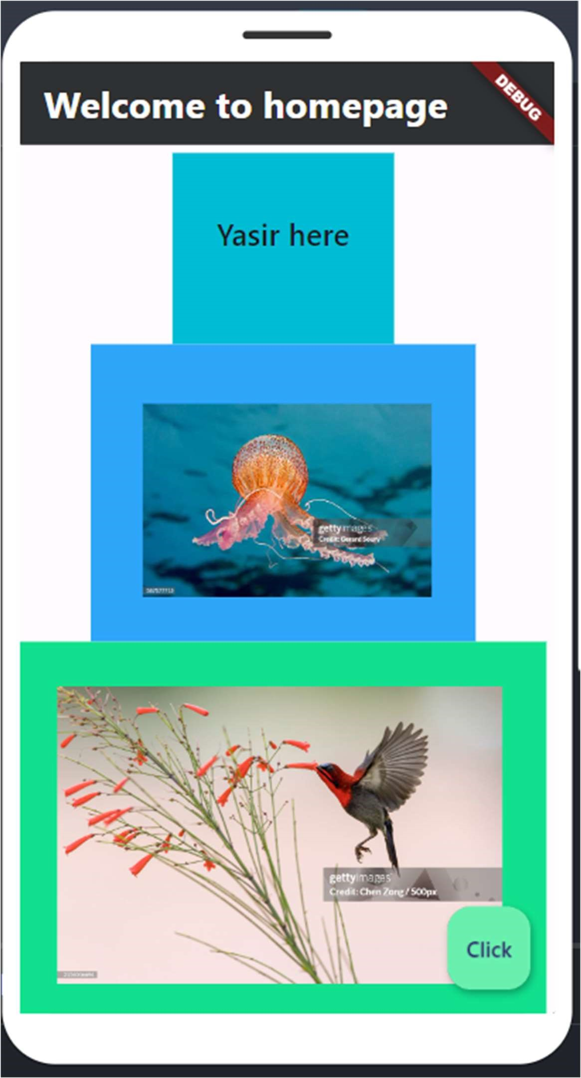 ),

],

),

floatingActionButton: FloatingActionButton(

onPressed: () {}, backgroundColor: Colors.greenAccent,

child: Text("Click"),

), ),

),

);